Underwater View Real-Time Simulation

Dmitry I. Abrosimov,
Intel Nizhny Novgorod Lab (iNNL),
Nizhny Novgorod, Russia.

Annotation

The paper discusses various aspects of the waved water surface and underwater bottom video representation simulation and also expands on the math models and algorithms of the following related tasks:
— waved water surface simulation;
— calculation of reflected and refracted rays directions in 3-D space;
— underwater caustics (extra illuminated areas) forming;
— refractive distortion of the bottom view account;
— reflected skylight addition.
The ’Breeze’ Microsoft* Windows* demo application realizes all described algorithms and enables real-time simulation of the underwater view.
The paper also assesses the efficiency of the Intel® Integrated Performance Primitives used in this application. Presented images illustrate all optical effects described in the paper.

Introduction

Despite certain achievements in the area of waved water surface video representation (see, for example, [1-6]), each work in this subject must be viewed as relevant. This article describes a physical model that was used in the development of the ‘Breeze’ Microsoft* Windows* demo application designed for modeling of underwater view video representation in real time. Unlike the algorithm described in [6], ‘Breeze’ application simulates more optical phenomena, namely light reflection, refraction and focusing by the waved water surface. The last one leads to forming of so-called caustics (intensively illuminated lines and shapes) on the bottom. Both algorithms have advantages and disadvantages, which will not be discussed in detail in the frames of this paper.
To increase the performance rate, we used the Intel® Integrated Performance Primitives (IPP) library [7]. Destination and capabilities of this software are briefly described in in section 5. As shown in that section, utilization of the IPP library enables to increase the performance rate by 3-5 times.

1. Algorithm

Video representation of the sea bottom, under the waved water, surface is built as a sequence of frames, each corresponding to the current time moment. The procedure of the building the frames is divided into the following steps.
- Simulation of the waved surface, namely, calculation of the surface elevation z(x, y, t) and its declination angels (∂z/∂x and ∂z/∂y) as functions of the horizontal plane coordinates x, y and time t. The simulated surface must have characteristics more or less close to the ones of the real water surface.
- Calculation of reflected and refracted ray directions in each point of the surface (separately for the solar and view rays). This step is the most complicated and requires substantial computational resources.
- Calculation of the number of refracted solar rays found for each bottom point to define illuminance in that particular point.
- Calculation of coordinates where the view ray finds the bottom after refraction (those coordinates are necessary to build a distorted bottom view).
- Calculation of the reflection coefficient in each surface point (to use together with the reflected ray direction to build the skylight reflection effect).
- Frame forming, that is, reflected skylight and caustics effects adding to the bottom image (previously read graphical file) and its refraction distortion performing.
- Perspective transforming of the frame.
Described procedure is repeated for each frame with the next value of t to simulate video representation of the sea bottom view. The following sections offer more details on these steps.

2. Water Surface Modeling

Waved water surface is simulated with the use of the 2-dimensional Fast Fourier Transform (2-D FFT) algorithm. This transform takes complex 2-D surface elevations spectrum S(k_{x}, k_{y}, t) (defined in the wavenumber space k_{x}, k_{y}) and calculates those elevations z(x, y, t). When the first frame is calculated
(t = 0), the spectrum magnitude 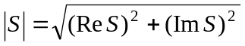 is assigned as a determined function, and its phase 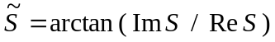 – as a random equally distributed in [0, 2π) interval value 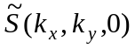. During the calculation of every next frame we get the current time t and just add the product ωt to the initial phase of each spectral component:

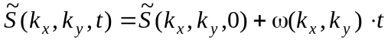. (1)

The cyclic frequency ω depends on the wavenumbers with the well-known dispersion relation for gravity waves:

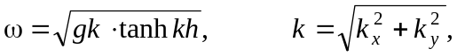 (2)

where g = 9.81 m/s² – gravity acceleration, h – water depth.
The 2-D FFT algorithm has several peculiarities: its input and output data are 2-dimensional complex arrays (S_{ij} = S(k_{i}, k_{j}) and z_{ij} = z(x_{i}, y_{j}) respectively) given on 2-D rectangular grids

k_{i} = i⋅Δk_{x}, k_{j} = j⋅Δk_{y},
x_{i} = i⋅Δx, y_{j} = j⋅Δy,
Δk_{x} = 2π/X, Δk_{y} = 2π/Y,
Δx = X/N_{x}, Δx = Y/N_{y},
i = 1, …, N_{x}, j = 1, …, N_{y},

where X and Y are water area sizes in the horizontal plane. Note, that the array elements numbers N_{x} and N_{y} must be integer powers of two only (that is, 64, 128, 256, 512, 1024, …), which is another peculiarity of the FFT algorithm. Whereas surface elevation is a real value, the simplest way is to use only Re(z_{ij}). In this case, we should simulate waves progressing in one direction. To get a coincident wave, we should add one more wave Im(z_{ij}), progressing in the inverse direction (indexes i, j should be changed to N_{x}-i, N_{y}-j).
Experience has shown that the video representation reality highly depends on the form of spectrum. We tried a number of S(k_{x}, k_{y}, t) dependencies and opted for the Gaussian

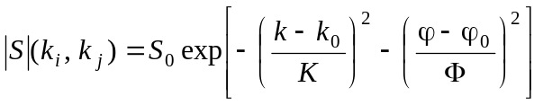 (3 a)
and double Gaussian
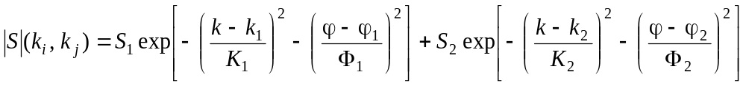 (3 b)
relations (here 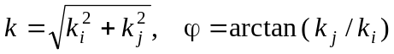). Values of k_{0,1,2}, ϕ_{0,1,2}, K, K_{1,2}, Φ and Φ_{1,2} may vary. The (3a) dependence describes propagating in the single direction quasi-plane wave and (3b) – superposition of two such waves, propagating at angle of each other.
The next step is the calculation of the surface inclination angles (the same – partial derivatives)

ξ_{x} = ∂z/∂x = (z_{i+1, j} - z_{i, j}) / Δx, (4 a)

ξ_{y} = ∂z/∂y = (z_{i, j+1} - z_{i, j}) / Δy. (4 b)

Since this calculation does not present produce any difficulty, we do not cover it in detail in this paper.

3. Reflection and Refraction

This section describes an algorithm to calculate reflected and refracted ray directions. These calculations are sufficiently complicated and are comprehensible in detail only for experts in 3-D computational geometry. Note that this part of algorithm requires much time (even more than FFT). One of the reasons for the substantial time requirement is the need to perform the calculations twice: for solar and view rays. Refraction of the solar rays may lead to light focusing on the bottom, which is the reason for the appearance of caustics. Refraction of the view rays leads to distortion of the bottom view, and calculation of their reflection direction is necessary to add the skylight. Those effects are discussed in the next section.
Any direction in 3-D space may be determined by the unitary vector r, or by its three components 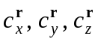 that are usually named as directional cosines. Those components are connected by the following relation: 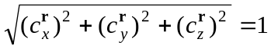. If we know the components of the incident ray r_{inc}, components of the surface normal (unitary vector perpendicular to the surface) n in the incidence point, and refractive coefficient of water, we may uniquely calculate components of the reflected r_{refl} and refracted r_{refr} rays unitary vectors (see Fig. 1). Therefore, the first step is to calculate the components of the surface normal 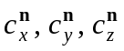 connected with inclination angles (4):

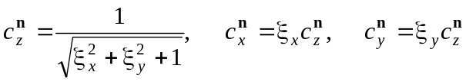. (5)

Let’s define a new coordinate system 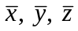 rotated relatively to the old one x, y, z in such way that the axis coincides with the direction of n and the r_{inc} vector is situated in 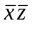 plane. The matrix of this rotation transformation
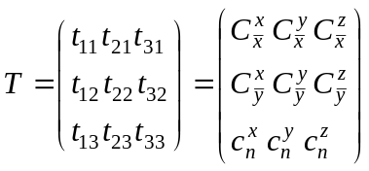, (6)
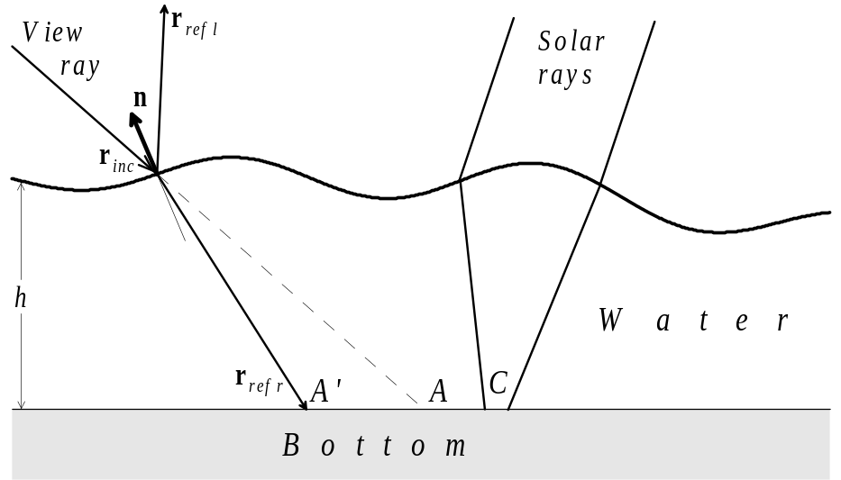

Fig. 1. Rays reflection and refraction

where

, (7 a)

, (7 b)

, (7 c)

connects old and new coordinates:

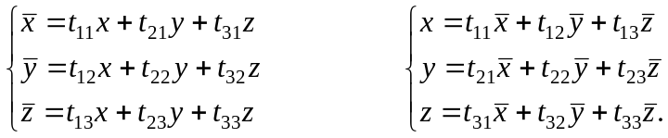 (8 a, b)

Directional cosines 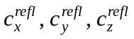 of the reflected ray direction are determined after double application of transformations (8): first (8a) transformation is applied to the vector r_{inc} coordinates 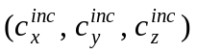, then evident relations
(9)

are used, and lastly, (8b) transformation is applied to 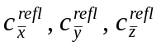.
Refracted rays unitary vector components 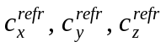 are calculated in a similar way. The difference is that we must substitute (9) relations by:
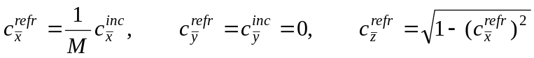, (10)

where M ≈ 1,34 is the refraction coefficient (index) of water.
Cosine of the incident ray dip angle ψ (angle between r_{inc} and n)

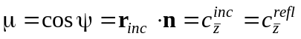 (11)

determines the power reflection coefficient R for r_{inc} (well-known Fresnel’s formula):

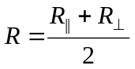, (12 a)

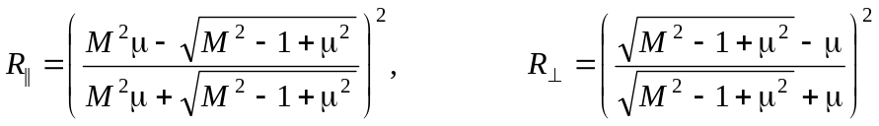. (12 b)

4. Caustics, Distortion, Skylight Illumination, and Perspective Transform

Caustics are extra illuminated bottom regions caused by the refracted solar rays focusing (region C in Fig.1). This section describes the algorithm of bottom illuminance distribution calculation. Assume that a solar ray meets the water in the surface point with indexes i, j and elevation z_{ij}; then this ray is refracted and meets the bottom in some point. Physical coordinates x_{refr}, y_{refr} and array indexes i_{refr}, j_{refr} of this point are the following:
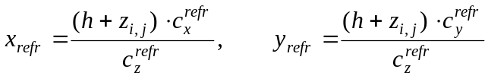, (13 a)
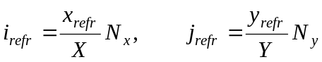, (13 b)

where are directional cosines of the refracted ray (see section 3), h is the average depth of water. We must calculate how many refracted rays meet at each point (to put it more precisely, each elementary area) of the bottom. For that we must allocate a 2-D integer array m that keeps these numbers. Then we must calculate solar refracted rays directions and indexes i_{refr}, j_{refr} for all the water surface points (1≤i≤N_{x}, 1≤j≤N_{y}) and just add one to each m(i_{refr}, j_{refr}). Calculation of the “illuminated” bottom image may be performed by multiplication of the initial image color components by some function F of m(i, j). For our purposes, we used the following function:
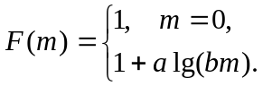 (14)

Coefficients a and b are chosen experimentally and may differ for red, green and blue components.
Distortion of the bottom view takes place due to the view rays refraction. If the view ray does not change direction and meets the bottom in point A (see Fig. 1), there would be no distortion. To form distorted bottom image, we must calculate incident points indexes (using (13) relations) for each of N_{x}×N_{y} view rays and then copy (i_{refr}, j_{refr}) element of the initial bottom image to the (i, j) element of the distorted image. Note that dip angles of solar and view rays may differ, so all calculations must be performed twice (our experience has shown that if the solar and view ray directions coincide, the picture is not realistic).
Adding reflected skylight may improve the picture reality. Calculation of the reflected direction of the view ray is described in section 3. In the frames of our model, we assume that the sky light brightness is constant, that is, direction-independent, so the reflected brightness component B_{refl} depends on the reflection coefficient R only. This coefficient may be calculated exactly with the use of Fresnel’s formula (13). Taking into consideration that this formula is rather complicated, we have gathered a simple fit dependence R(cos ψ):
R(cos ψ) = 0.02 + 0.98⋅exp(–6.3⋅cos ψ). (15)

The following is the experimentally found resulting relation for B_{refl}:

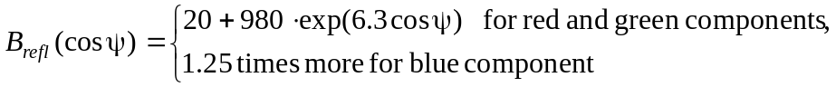 (16)

Note that the maximal value of each color component is clamped to 255. All color components of B_{refl} must be calculated for all N_{x}×N_{y} points of surface and added to the frame image.
The last step is the application of the perspective transform. This conversion is used to change the look of the bottom depending on the angle at which the observer sees the bottom. This paper does not offer any formulas of perspective transform because we used an Intel Integrated Performance Primitives function for this purpose. The IPP image processing library includes a number of geometrical conversions functions and perspective transform among them.
At the end of this section, we would like to provide visual examples to illustrate all optical effects described above. Fig. 2 presents one of the used images, the fish tank view (a) and shows how it changes if caustics (b), refractive distortion (c), skylight reflection and perspective transformation (d) are added.

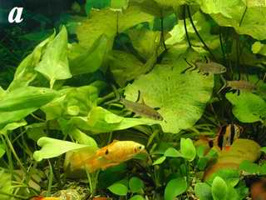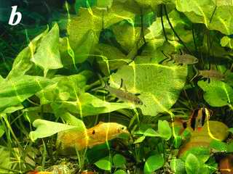

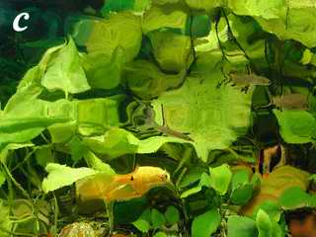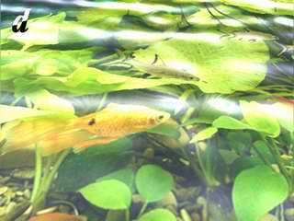

Fig. 2. Optical effects and transforms. a – initial view, b – caustics addition, c – refractive distortion,
d – skylight reflection and perspective transformation.

5. Intel® Integrated Performance Primitives and Performance Speed

Intel Integrated Performance Primitives (IPP) [7] is a software library that provides a variety of multimedia functions for developing high performance applications. This software includes a number of library segments, each of which is highly optimized for the use with one of the Intel® processors (including the Intel Pentium® 4 processor, Intel Itanium® processor, and Itanium 2 processor). The IPP library is very effective for processing data arrays, such as vectors, matrices, images, etc. In this case application performance rate may increase highly. The other purpose of the IPP library is to simplify code writing. IPP includes functions that are often used in different calculation regions, such as vector and matrix algebra, image development, etc.
To prove the efficiency of the use of the IPP software library, a performance test of the ‘Breeze’ application was carried out. Computers based on two different processors, a 700 MHz Intel Pentium III processor and a 2000 MHz Intel Pentium 4 processor, were used. Two modifications of the application were optimized for the Pentium III processor and Pentium 4 processor respectively (these modifications differ from each other by the IPP optimization variants they use and by compiler presets). Both programs were compiled by the Intel C++ compiler [8]. The Pentium III processor does not support some Pentium 4 processor instructions, thus it was tested only with the first modification. All the tests were performed with picture resolution 512×384 pixels.
The results of the test are presented in Fig. 3. The figures above columns show averaged performance rate in frames per second; the blue columns correspond to IPP disabled mode, the yellow ones correspond to IPP enabled mode. The figure proves that the use of the most optimized IPP library segment in combination with the optimal compiler presets may significantly enhance the application performance.

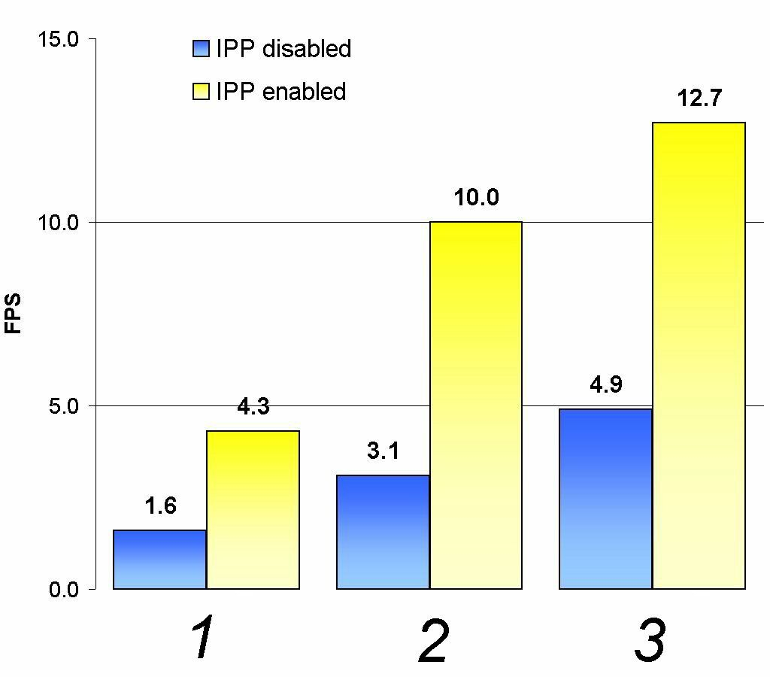

Fig. 3. ‘Breeze’ application performance rate in frames per second shown on (from left to right): the Pentium III processor (1), Pentium 4 processor using the Pentium III processor-optimized library (2), and Pentium 4 processor using the Pentium 4 processor-optimized library (3)

References
- Lasse S. Jensen and Robert Golias. “Deep-Water Animation and Rendering”. http://www.swrendering.com/papers/deep_water_animation_and_rendering.pdf
- Jerry Tessendorf. “Simulating Ocean Water”. SIGGRAPH 2001 Course notes. http://home1.gte.net/tssndrf/index.html
- Miguel Gomez. “Interactive Simulation of Water Surfaces”. Game Programming Gems. ISBN 1-58450-049-2.
- Nick Foster and Dimitri Metaxas. “Realistic Animation of Liquids”. Graphical Models and Image Processing, 58(5), 1996, pp.471-483.
- Gary A. Mastin, Peter A. Watterger, and John F. Mareda, “Fourier Synthesis of Ocean Scenes”, IEEE CG&A, March 1987, p 16-23.
- Dmitry Abrosimov, Victor Zelenogorsky, Michail Kryukov. “Computer Simulation of Water Surface View”. Proceedings of the 9-th International Conference on Computer Graphics and Vision (GRAPHICON-99). Moscow, MSU, 1999, pp. 255-260 (in Russian).

- http://developer.intel.com/software/products/ipp/ipp30/

- http://developer.intel.com/software/products/compilers/

© Intel Corporation.
© Author – Dmitry I. Abrosimov.
Web publication: http://www.osnews.com/story.php?news_id=3348 (Apr. 21, 2003)

